kubernetes Task 06

Create a ConfigMap from a directory containing multiple files and inject the variables into a pod as environment variables.
Create directory
|Config_dir | /app.properties
| /db.properties
# mkdir config-dir
# cd config_dir
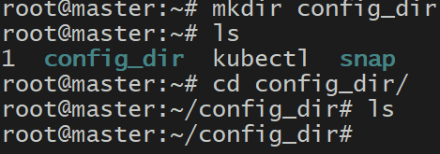
# Vi app.properties -- > APP_NAME=MyApp
APP_ENV=Production
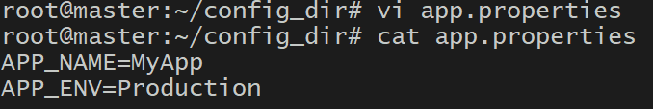
# Vi db.properties -- > DB_HOST=mysql-service
DB_USER=admin
DB_PASS=secret123
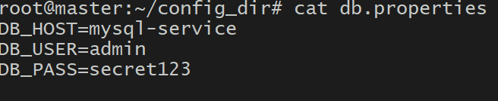
Create a ConfigMap from the directory
# kubectl create configmap my-config --from-file=config_dir/
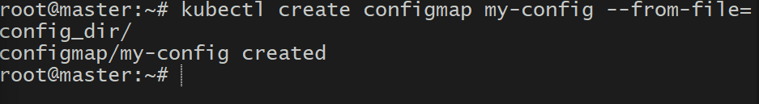

# kubectl describe configmap my-config
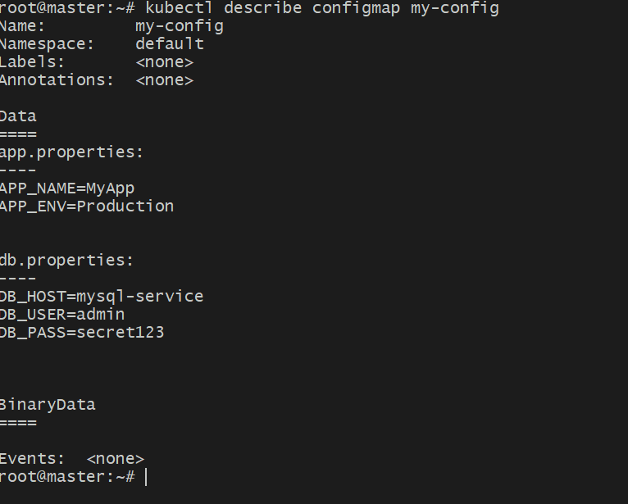
  - Inject ConfigMap values as environment variables
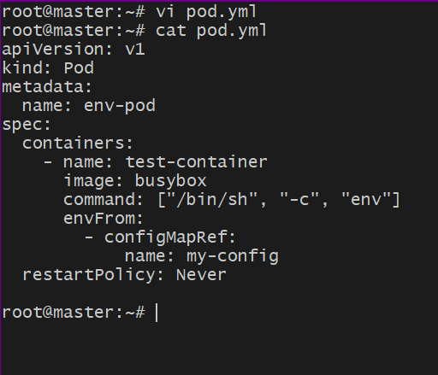
# vi pod.yml - >
apiVersion: v1
kind: Pod
metadata:
name: env-pod
spec:
containers:
- name: test-container
image: busybox
command: ["/bin/sh", "-c", "env"]
envFrom:
- configMapRef:
name: my-config
restartPolicy: Never

# kubectl apply -f pod.yml
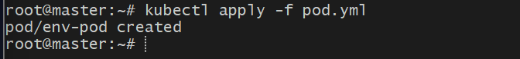
# kubectl logs env-pod
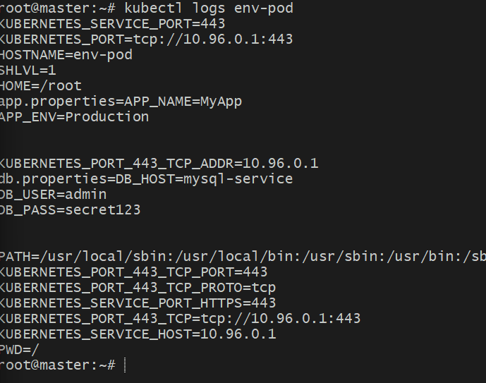

Create a ConfigMap from a file and mount it as a volume inside a pod, ensuring the configuration data is available as files.
# vi app-config.txt -- >
APP_NAME=MyVolumeApp
APP_ENV=Development
DB_HOST=mysql
DB_USER=root
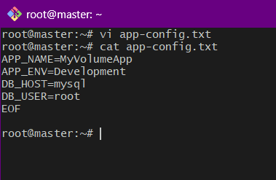
# kubectl create configmap app-config --from-file=app-config.txt
# kubectl describe configmap app-config
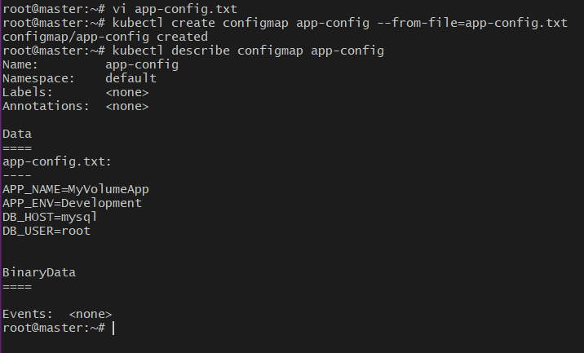

# vi pod-configmap-volume.yml
apiVersion: v1
kind: Pod
metadata:
name: configmap-volume-pod
spec:
containers:
- name: test-container
image: busybox
command: ["/bin/sh", "-c", "cat /etc/config/app-config.txt; sleep 3600"]
volumeMounts:
- name: config-volume
mountPath: /etc/config
volumes:
- name: config-volume
configMap:
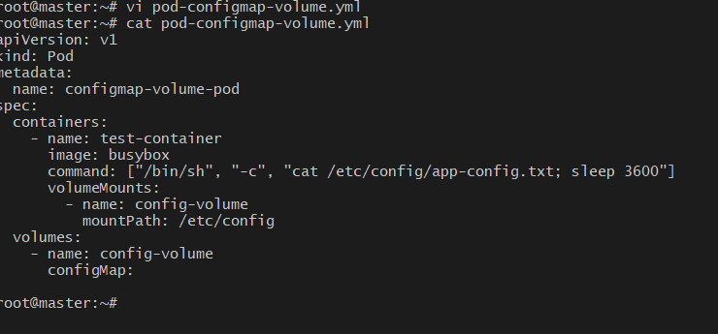
# kubectl apply -f pod-configmap-volume.yml
# kubectl exec -it configmap-volume-pod -- cat /etc/config/app-config.txt
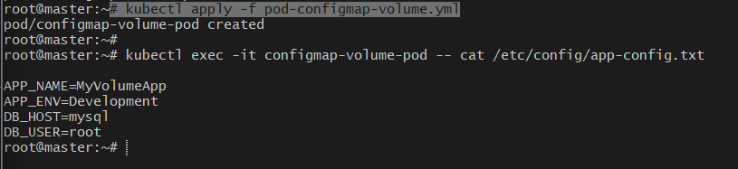

Create a Secret with sensitive information (username and password) and inject it into a pod as environment variables.
You can create it directly from literal values using the command line:
# kubectl create secret generic db-secret \ --from-literal=username=admral \ --from-literal=password=MyP@ssw0rd
# kubectl describe secret db-secret
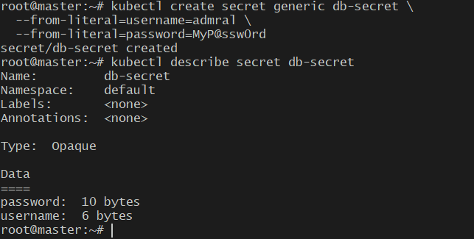
# kubectl get secret db-secret -o yaml
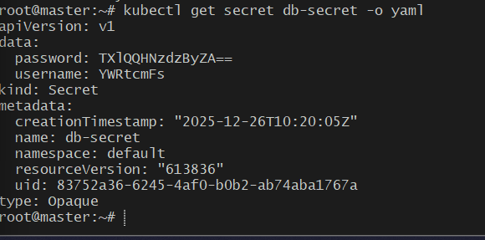

Create a Pod definition file named # vi secret-env-pod.yml:
apiVersion: v1
kind: Pod
metadata:
name: secret-env-pod
spec:
containers:
- name: test-container
image: busybox
command: ["/bin/sh", "-c", "echo Username=$USERNAME; echo Password=$PASSWORD; sleep 3600"]
env:
- name: USERNAME
valueFrom:
secretKeyRef:
name: db-secret
key: username
- name: PASSWORD
valueFrom:
secretKeyRef:
name: db-secret
key: password
restartPolicy: Never

# kubectl delete pod secret-env-pod
# kubectl apply -f secret-env-pod.yml
# kubectl get pods
# kubectl logs secret-env-pod

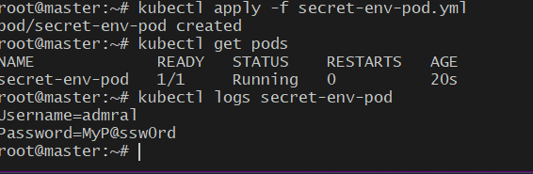

Create a Secret using a YAML file, mount it as a volume in a pod, and verify the specific Secret values are available as files.
# vi secret.yml
apiVersion: v1
kind: Secret
metadata:
name: db-secret
type: Opaque
data:
username: YWRtaW4=
password: TXlQQHNzdzByZA==
# kubectl apply -f secret.yaml
# kubectl get secrets db-secret -o yaml
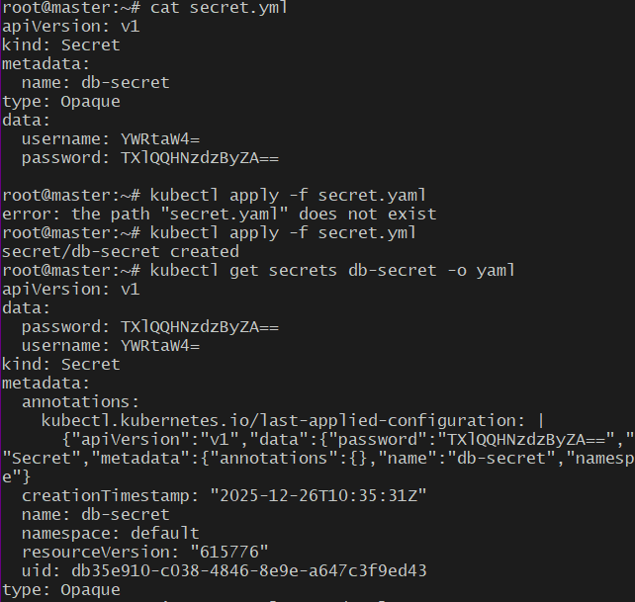

# kubectl exec -it secret-volume-pod -- ls /etc/secret-data
# kubectl exec -it secret-volume-pod -- cat /etc/secret-data/username
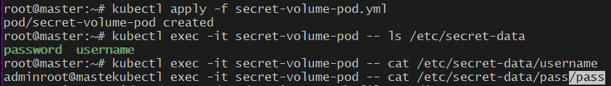

Inject a ConfigMap as environment variables and a Secret as files into the same pod, ensuring both are accessible within the pod.
# vi app-configmap.yml
apiVersion: v1
kind: ConfigMap
metadata:
name: app-config
data:
APP_NAME: "MyApp"
APP_ENV: "Production"
DB_HOST: "mysql-service

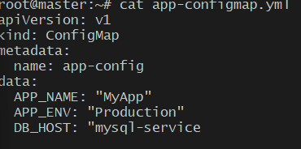
# kubectl apply -f app-configmap.yml
# kubectl get configmap app-config -o yaml
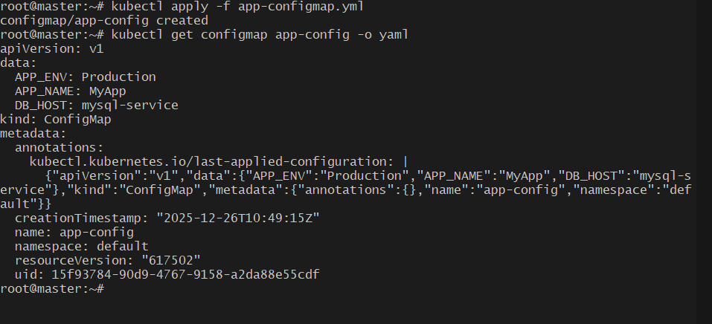
# vi pod-config-secret.yml
apiVersion: v1
kind: Pod
metadata:
name: config-secret-pod
spec:
containers:
- name: test-container
image: busybox
command: ["/bin/sh", "-c", "echo '--- ENV VARIABLES ---'; env | grep APP_; echo '--- SECRET FILES ---'; ls /etc/secret-data; echo '--- FILE CONTENTS ---'; cat /etc/secret-data/username; echo ''; cat /etc/secret-data/password; sleep 3600"]

# Inject ConfigMap as environment variables
envFrom:
- configMapRef:
name: app-config

# Mount Secret as files
volumeMounts:
- name: secret-volume
mountPath: "/etc/secret-data"
readOnly: true

volumes:
- name: secret-volume
secret:
secretName: app-secret

restartPolicy: Never
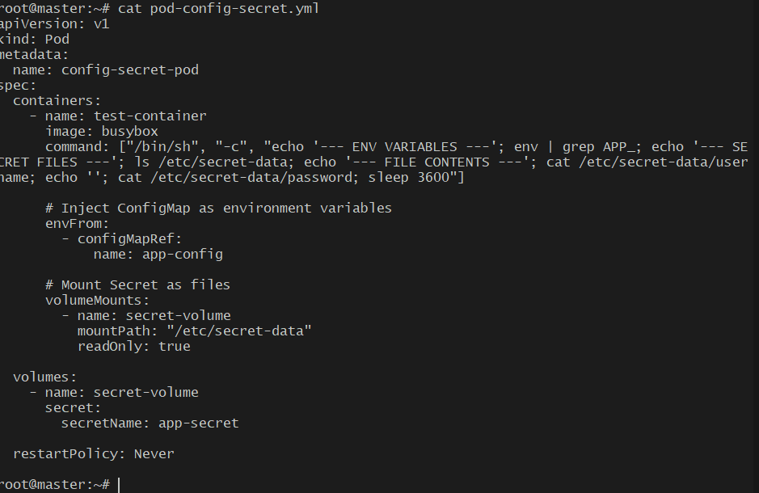
# kubectl apply -f pod-config-secret.yml
# kubectl exec -it config-secret-pod -- env | grep APP_
# kubectl exec -it config-secret-pod -- ls /etc/secret-data
# kubectl exec -it config-secret-pod -- cat /etc/secret-data/username
# kubectl exec -it config-secret-pod -- cat /etc/secret-data/password
